



NAME – ABHRANIL PAUL
CALSS – XII
SECTION - A
PLASMA IONIC THRUSTER
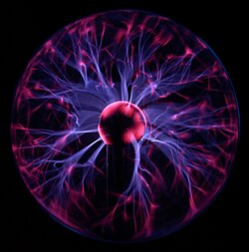

INDEX
- Introduction
- Objective
- Scientific Principle & Physics
Involved
- Materials Required
- Construction of the Model
- Working of the Model
- Observations
- Illustration
- Used in Space Mission
- Innovative Applications & Future Scope
- Conclusion
- Bibliography
Introduction
Most rockets and satellites today use chemical fuel, which is costly, heavy, and harmful to the environment. Plasma thrusters, used in space, are highly efficient and use very little fuel. This project is not only a model of an ion thruster but also an innovative idea to adapt this technology for Earth. It uses plasma (ionized air) to produce thrust without moving parts or combustion. On Earth, this idea can be used in pollution-free vehicles, drones, cooling systems, and futuristic transport.

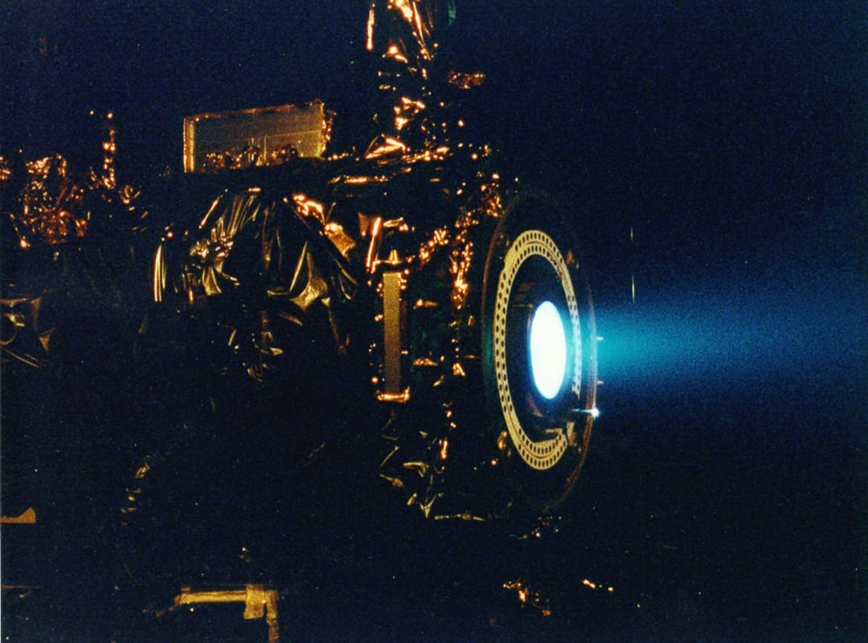
Objective
- To demonstrate how plasma is formed and produces thrust.

- To design an innovative concept for eco-friendly propulsion on Earth.

- To study how this technology can be scaled for space and on Earth.

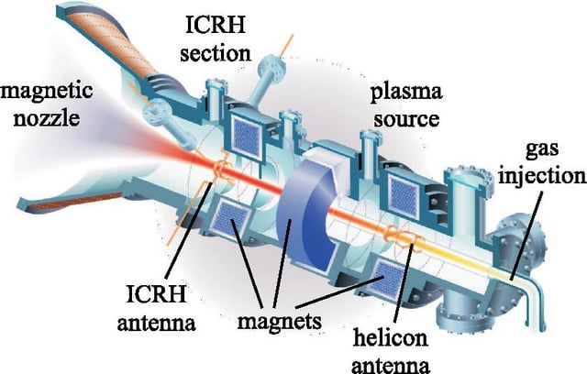

Scientific Principle & Physics Involved
Scientific Principle
- A high electric field between fine-pointed electrodes ionizes air and accelerates ions, generating thrust.

- Plasma, the fourth state of matter, is formed when gas is ionized.

- Movement of charged particles under an electric field converts electrical energy into kinetic energy.
Physics Involved
- Coulomb Force: Electric field applies force on ions, making them accelerate.

- Newton's Third Law: The acceleration of ions in one direction creates an equal and opposite reaction, producing thrust.

- Electrostatic Acceleration: Difference in electric potential accelerates ions, similar to ion thrusters in space.
Materials Required
- Battery (up to 12V) - Power source for the high voltage generator.

- High Voltage Generator - To generate the required high voltage for ionization.

- Copper Ring (Positive Terminal) - Acts as the anode to repel positive ions.

- Tin Ring with Pointed Ends (Negative Terminal) - Acts as the cathode for electron emission.

- Switch - For turn the circuit ON and OFF.

- Connecting Wires - For making electrical connections.

- Non-Conductive Base - For mounting all components safely.

- Insulating Stand - To hold the electrodes and maintain safety from high voltage.
Construction of the Model
- Fix two electrodes (copper ring & point ends tin) on an insulated base at a small distance apart.

- Connect the electrodes to the high-voltage DC power supply using insulated wires.

- Ensure proper insulation to prevent leakage of current and maintain safety.

- Add a switch in the circuit to control the power supply.

- When the power is turned on, a strong electric field forms between the electrodes, ionizing the air and generating plasma.

- The accelerated ions move toward the opposite electrode, creating a small thrust in the surrounding air.

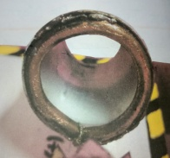 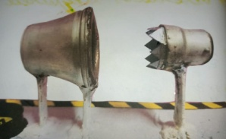 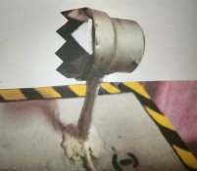
Working of the Model
- When the power supply is switched on, high voltage is applied between the copper ring and the pointed electrode.

- This high voltage creates a strong electric field near the pointed electrode.

- The electric field ionizes the surrounding air molecules, forming plasma (charged particles).

- These ions are accelerated towards the opposite electrode due to the electric field.

- The movement of charged particles creates a small thrust.
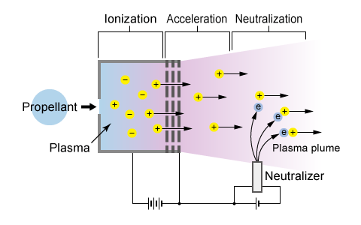
Observation
- When the power supply is turned on in a slightly dark environment, a visible purple plasma is observed near the pointed electrode.

- The plasma stream moves from the pointed electrode toward the copper ring, indicating ionized particle movement.

- A faint buzzing sound is heard during operation, confirming high-voltage ionization.

- From the end of the copper funnel, a gentle thrust is felt as the accelerated ions push air molecules forward.

- The glow becomes stronger as the voltage increases, indicating higher ionization of air.

- No visible spark occurs if the distance and voltage are maintained properly.
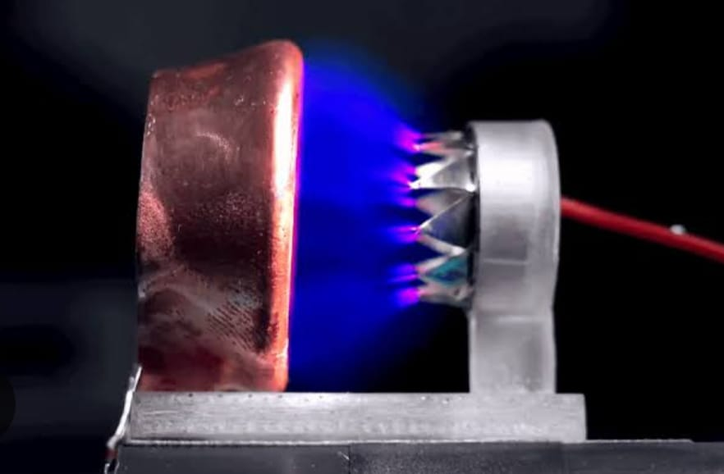
Illustration

Circuit Diagram of Plasma Ionic Thruster
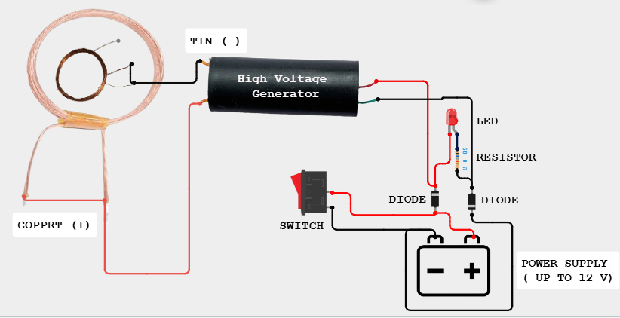
Used in Space Mission
Provides efficient propulsion by ionizes xenon for long duration space missions.
Benefits in Space
- Fuel Efficiency – Uses very little propellant (like xenon gas).
- Long Operation Time – Can work for months or years.
- Precision – Can make small, controlled adjustment in satellite positions.
- Light Weight – Reducing space craft mass.
Problems Faced in Space
- Low thrust - Cannot launch from Earth.
- Sunlight dependence - Far from the Sun, electricity is limited.
- Limited propellant - Stops working if gas runs out.
- Complex and expensive technology.
Examples of Space Missions
- NASA's Dawn & DART Missions.
- ESA'S SMART-1.
Innovative Applications & Future Scope
Innovative Applications
- Renewable propulsion on Earth - Small-scale ion engines could power drones or cargo vehicles with minimal fuel and low pollution.
- Clean energy transport - Could replace non-renewable sources in transport systems, reducing emissions.
- Precision cargo movement in orbit - Move satellites or space station modules accurately without large rockets.
- Enhanced airflow systems - Ionic wind technology could enable efficient, silent cooling systems without fan blades.
- Silent propulsion aircraft - Future aircraft could use ionic propulsion for quiet, low-pollution flight.
Future Scope
- Scale-up for quiet drones or eco-friendly personal aircraft.
- Combining with solar power to create carbon-free propulsion systems.
Conclusion
- Plasma/ion thrusters are a highly efficient and advanced propulsion technology.

- They provide continuous, low-thrust propulsion with minimal fuel, making them ideal for space exploration.

- Their precision, long operational life, and renewable energy use make them promising for future applications both in space and on Earth.

- Future innovations could bring ionic propulsion into everyday life, including silent transport, clean energy systems, efficient cooling, and environmental cleanup.

- With ongoing research, plasma/ion thrusters have the potential to revolutionize sustainable transport, deep space missions, and low-pollution technologies.

Bibliography

- NCERT Physics Class 12 - Chapter on Electric Charges & Fields.

- WWW.nasa.gov - NASA Ion Propulsion Info.

- Wikipedia - Ion Thruster.

- Personal Experimentation and Observations.



